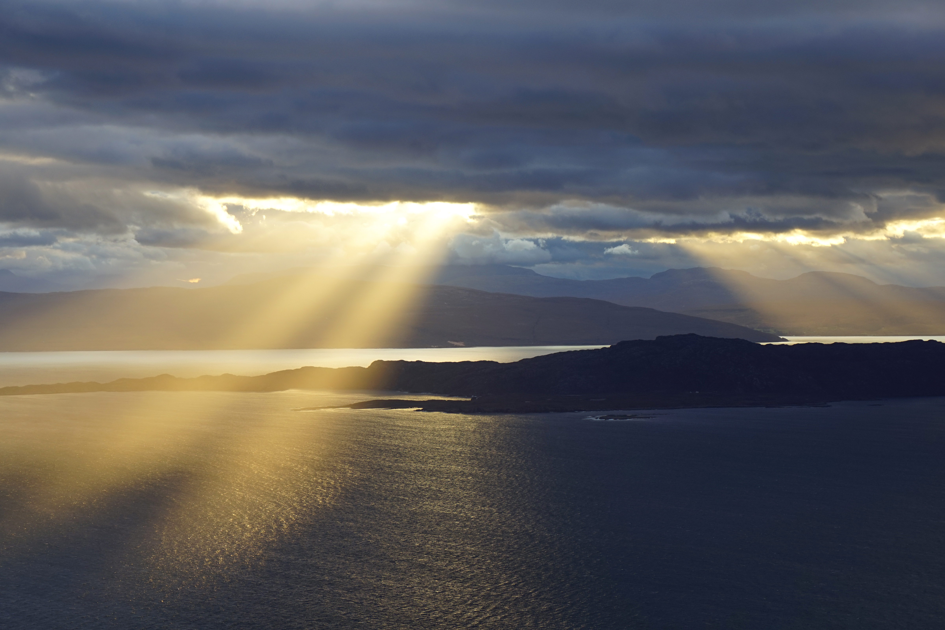
REQUIEM OF PSALMS (PART 3 OF THE SUNSET REQUIEM TRILOGY) - (COVID REQUIEM)
Whither shall I go from thy spirit? or whither shall I flee from thy presence?
If I ascend up into heaven, thou art there: if I make my bed in hell, behold, thou art there.
If I take the wings of the morning, and dwell in the uttermost parts of the sea;
Even there shall thy hand lead me, and thy right hand shall hold me. (Psalm 139:7-12)

INTRODUCTION - WHITHER SHALL I GO?
The Requiem of Psalms forms the concluding part of Jonathan Crow's "Sunset Requiem" Trilogy. It continues the journey into sunset and beyond and takes its inspiration from the Psalms, in particular the question “Whither shall I go?”.
The Scottish roots of the composer can be felt throughout, nowhere more so than in the opening Highland Lament which describes a final voyage across the ocean as a couple sing their last farewell to their homeland. "Can you see beyond the sunset?" The rocking of the boat on the waves can be felt in the refrain "Come with me one last time"
The theme of making a momentous journey continues throughout the work as the movement titles indicate - "Whither shall I go?", "Yea though I walk through the valley", "Beside still waters He leadeth me".
At the heart of the work is the idea that life itself is a journey and we are not alone. God our Shepherd leads us and comforts us and lights our way even to the darkest place and deepest depths. The restless and energetic setting of "Whither shall I go" from Psalm 139 for solo bass and violin in particular is very powerful as we question the direction of our own lives, where are we going? And the comforting answer always comes back - wherever we go, "Even there Thou art there"
THE INSPIRATION
WHY A REQUIEM OF PSALMS?
The book of psalms is a treasury of spiritual reflection and illumination on the meaning of life and death and lends itself perfectly to a Requiem setting .
All the psalms are addressed to God, some give thanks for what God has done while others beg for help in a time of crisis. Because the psalms are so personal and portray such genuine human emotion, they remain as powerful today as when they were written, over 2000 years ago.
With their rich imagery, whether it is of wild flowers, islands on the edge of the sea, deep and dark valleys, soaring mountains, still waters, the psalms speak to us and can take us to a place where we can contemplate our deepest needs if not the very meaning of life. These images are taken up in the Requiem and expressed in music of great richness, variety and beauty.
THE MUSIC
COMPOSITION
The work was composed for the most part in 6 months from June to December 2019 and builds on the experiences of Jonathan Crow's first two parts of Sunset Requiem. However, three movements date from much earlier, the setting of "Whither shall I go?" is based on material from an earlier work composed for his grandmother in the 1980s, "The Lord bless you and keep you" comes from his musical based on the Exodus Story composed in the 1990s whilst the setting of Psalm 23 was composed for his mother also in the 1990s.
THEMATIC STRUCTURE
The work follows a similar structure of the previous Sunset Requiems comprising multiple short movements. It is structured in 4 main parts, each of which seeks a different place after the opening cry of anguish.
- Following the opening Lament, Part 1 is a heartfelt cry from the depths of despair, the De Profundis ("Out of the Depths") Psalm 130
- Part 2 seeks a place of illumination and quiet with the words of Psalm 18 - "Light in darkness" ("Keep my lamp burning")
- Part 3 seeks a place of uplift and safety with the words of Psalm 121 - "Lift up your eyes" ("Yea though I walk through the valley")
- Part 4 seeks a place of comfort and reassurance in the words of "In Paradisum" ("Beside still waters") .
The Requiem is scored for a soloist ensemble and the different combinations of voices and instruments in the various movements allow different shades and illuminations of the selected Psalms to be felt in familiar and much loved verses
MUSICAL HIGHLIGHTS
HIGHLAND LAMENT
The Requiem opens unusually with a Highland Lament which expresses the central theme of momentous, life-changing journeys and the abiding question Whither shall I go? The inspiration comes from the Highland Clearances and the picture is of a sea voyage into the unknown.
OUT OF THE DEPTHS
The soul searching words of Psalm 130 - the great De Profundis - lend themselves to a Requiem setting. The movement was composed as tribute to the late assistant organist at Wotton Under Edge - Edmund ... who passed away in 2019.
WHITHER SHALL I GO
This is a striking movement inspired by the words of Psalm 139 set as an aria for solo bass in the style of Purcell . The question Whither shall I go? is heard throughout and the theme of momentous, life-changing journeys is expressed through key changes and sudden, dramatic shifts of key.
PSALM 23
This gentle, lyrical setting of the most well-loved of all the psalms - Psalm 23 in its entirety - is for the solo trio and comes at the heart of the Requiem. It offers respite after the restlessness of earlier movements such as Whither shall I go and the Highland Lament.
WHEN THE WIND BLOWS
Thoughts of life and death are expressed in the haunting solo movement "When the wind blows" which takes its inspiration from Psalm 103. Here we are reminded of the frailty of human life as we ponder the words - "Like wild flowers we bloom and die." The flute and soprano duet throughout with a beautiful melody to describe the beauty of wild flowers.
BESIDE STILL WATERS
There is something about the calm of still waters that can touch the human soul very deeply, and the image of Psalm 23 v 2 is conveyed in this solo movement with the triplet figure in the keyboard running throughout depicting water. The theme is a comforting one of being led by God beside still waters after the emotional torment of previous movements.
THE LORD IS MY LIGHT, MY SALVATION
The stirring and solemn finale - based on the opening words of Psalm 27 - is a reminder that God himself is our light and salvation. As the soloists sing at the close - He is truly our life, our soul. This is a fitting way to conclude a Requiem. Wherever our journeys lead us, God is our life, our soul. And at the end we come back to Him.

THE LANGUAGE
The majority of movements are written in English so as to convey the psalms in the most direct way possible. A small number of movements are in Latin based on the ancient form of the Requiem.

THE PREMIERE PERFORMANCE
The premiere performance will be at Holy Trinity Horfield, Bristol, on Saturday 6th November 2021 at 7.30pm. The performance is being given as a tribute to the victims of Covid in Bristol.
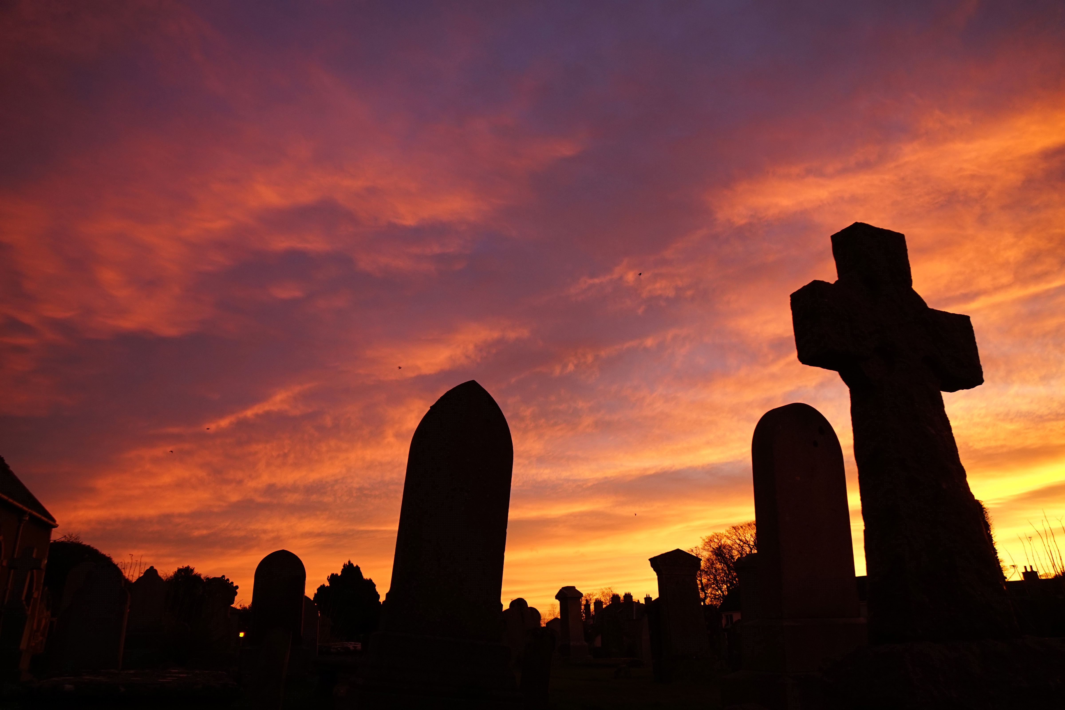
PROGRAMME
0 Overture
PART 1 – OUT OF THE DEPTHS (THE CRY)
1 Highland Lament – Can you see beyond the sunset?
2 Requiem aeternam Requiem text
3 Out of the depths (De profundis) Psalm 130 v1
4 Deep calls to deep Psalm 130 v2

PART 2 – KEEP MY LAMP BURNING (LIGHT IN DARKNESS)

5 You, O Lord, keep my lamp burning Psalm 18 v28
6 Whither shall I go? Psalm 139 v 7-11
7 The Lord bless you and keep you Numbers 6 v 24
8 Lux aeterna (Fuga) Requiem text

PART 3 – YEA THOUGH I WALK THROUGH THE VALLEY (LIFT UP YOUR EYES)

9 Yea though I walk through the valley Psalm 23 v 4
10 The Lord is my shepherd - Psalm 23
11 When the wind blows- Psalm 103 v 15-17
12 I will lift up mine eyes- Psalm 121

PART 4 – BESIDE STILL WATERS (IN PARADISUM)

13 Beside still waters- Psalm 23 v 2, 3
14 Agnus Dei Requiem text
15 In Paradise Requiem text
16 The Lord is my light, my salvation Psalm 27 v1

GUEST SOLOISTS
Rachel Gray, soprano
Brendan Casey, bass-baritone
Nick Sherwood, tenor
Helen Sherwood, violin
Linda Hansard, cello
Rachael Proud, flute
Jonathan Crow, organ
Eddie Garrard, conductor

